Grade 9 Science
- Chemistry Review –

Format
- Matching Section (Element Cards)
- Multiple Choice
- Short Answer (2-3 Bullet Points)

Elements 1-20 on the Periodic Table
- You should have the Elemental Symbol (1-2 letter abbreviation) memorized for
each Element (atomic numbers 1-20)
- You should be able to match an element with an important use that best fits it
- Periodic Table Song on YouTube: https://www.youtube.com/watch?v=-I7l8TgtuLQ
( / 40 Marks)

Classifying the Periodic Table
- If given a periodic table, you must be able to label the classifications and
periods, as well as explain what a period refers to.
- Practice this on the table provided:

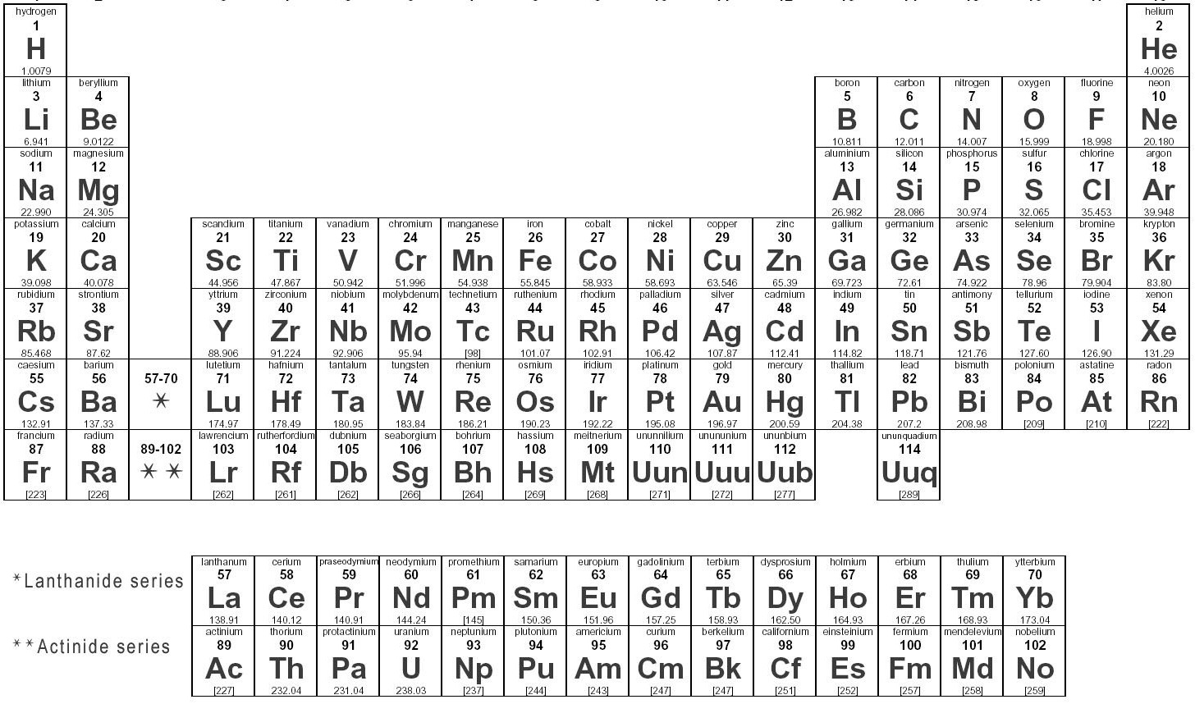

Compounds
- If given a compound name, you must be able to state if it is molecular or ionic,
and why. Complete the chart to help summarize this:
Compound Name | Chemical Formula | Ionic vs. Molecular | Why
Sodium Chloride
Methane
Carbon Dioxide
Calcium Flouride
Calcium Carbonate
Water
Phosphorus Tetraflouride

Subatomic Particles
- Complete the following chart to demonstrate your understanding of the
relationship between the different subatomic particles:
Element / Ion | Atomic Number  (Protons) | Mass Number  (Protons & Neutrons) | Charge | Protons  (Atomic #) | Neutrons  (Mass # - Atomic #) | Electrons  (= Protons)
²⁴Mg
¹²
³⁹K
¹⁹
²³Na⁺¹
¹¹
¹⁹F ⁻¹
⁹
²⁷Al⁺³
¹³
¹H
¹

Unit 2 Pre-Test-Chemistry
- Multiple choice:
- Oxygen is a metal
  - True
  - False
- Beryllium has 2 valence electrons
  - True
  - False
- In Lewis Dot diagrams the dots represent neutrons
  - True
  - false
- Which of the following is not one of the things Empedocles believed that everything was made of:
  - Wind
  - Air
  - Fire
  - Wood
- What is the atomic symbol for Iron
  - I
  - Au
  - Fe
  - Hg
- What charge does a neutron have
  - Positive
  - Negative
  - No charge
- What charge does an electron have
  - Positive
  - Negative
  - No charge

- What 2 sub atomic particles are found in the nucleus
  - Protons and Electrons
  - Neutrons and Electrons
  - Protons and Neutrons
  - Only electrons
- How many electrons can fit in the 2nd orbital on a bohr diagram
  - 2
  - 8
  - 16
  - 10
- If an element has a +1 charge then it has:
  - More electrons then protons
  - More protons then electrons
  - More protons then neutrons
  - The same amount of protons and neutrons
- If an element has 10 Protons and 10 Neutrons then:
  - It is Carbon
  - It has an atomic mass of 20
  - It has 20 electrons
- What pair of elements is in the same period
  - S and Ca
  - Li and K
  - O and F
  - Co and Ru
- What element is part of the Noble Gases
  - Fluorine
  - Argon
  - Calcium
  - Oxygen
- How many valence electrons does Carbon have
  - 1
  - 3
  - 4
- What element has the same number of valence electrons as Calcium
  - Oxygen
  - Sulfur
  - Chlorine
  - Magnesium
- What element is a metalloid
  - Be
  - B
  - C
  - Na
- What is NOT a physical property of table sugar?
  - white, crystalline solid
  - breaks down into carbon and water vapor when heated.
  - tastes sweet
  - dissolves in water
- What is a chemical property of baking soda
  - White
  - Powder
  - Reacts with vinegar
- How many Fluorine atoms are there in AlF₃
  - 1
  - 2
  - 3
  - 4
- How many Hydrogen atoms are needed to create 2CH₄
  - 2
  - 4
  - 6
  - 8

B) Long answer

- Draw the Bohr diagram for:
- K

- Si

- Ne

- Sort the following into the appropriate boxes. Each answer only fits in 1 box
- Roasting a marshmallow
- Baking soda and vinegar react
- Melting point
- Conducting electricity
- Melting cheese
- Basic
- Reacts with metals
- Dissolving koolaid in water
Physical Change | Chemical Change
Physical Property | Chemical Property

Additional Study Resources:
- In addition to this package, you can also study by visiting the resources available on our classroom website. To access these, please visit:
www.thompsonclassroom.weebly.com
- Grade 9 Science page
- Symbaloo (bottom of the page)
- Purple Icons

** This study guide is meant to be used as a general review, it should not be used exclusively. Please read over all class notes/materials in order to be fully prepared.

