Chemistry Unit Test
- Atoms, The Periodic Table, Bohr Diagrams, Compounds, Changes –

Name: _____________________________

Date: __________________________

Part A: Three Column Matching ( / 40 Total Points)
Match the elements in Column B with their elemental symbols in Column A.
Match the elements in Column B with the most appropriate use in Column C.
Column A Column B Column C
A. Al ____ Calcium ____ A. Air
B. Ar ____ Hydrogen ____ B. Air Pressure in Planes
C. B ____ Potassium ____ C. Balloons
D. Be ____ Helium ____ D. Bananas
E. C ____ Argon ____ E. Batteries
F. Ca ____ Lithium ____ F. Coal
G. Cl ____ Chlorine ____ G. Fertilizers
H. F ____ Beryllium ____ H. Flares
I. H ____ Sulfur ____ I. Gun Powder
J. He ____ Boron ____ J. Implants
K. K ____ Phosphorus ____ K. Insulation
L. Li ____ Carbon ____ L. Light bulbs
M. Mg ____ Silicon ____ M. Matches
N. N ____ Nitrogen ____ N. Milk
O. Na ____ Aluminum ____ O. Novelty/Advertising Lights
P. Ne ____ Oxygen ____ P. Petroleum
Q. O ____ Magnesium ____ Q. Pool Maintenance
R. P ____ Fluorine ____ R. Salt
S. S ____ Sodium ____ S. Tinfoil
T. Si ____ Neon ____ T. Toothpaste

Part B:Multiple Choice ( / 4 Points )
1 ) What is the chemical formula for the common compound, Methane:
(a) CO (b) CO₂
(c) C₄H (d) CH₄

** Use the blank Periodic Table to answer the remaining questions:
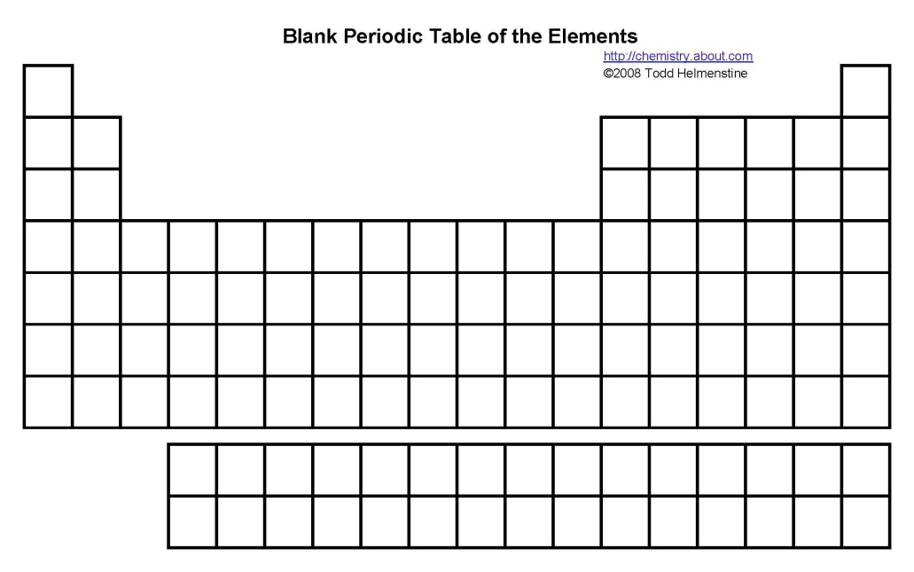
2 ) Which classification is below letter A?
(a) Alkali Metals (b) Noble Gases
(c) Transitional Metals (d) Halogens

3 ) Which classification is below letter B?
(a) Alkali Metals (b) Noble Gases
(c) Transitional Metals (d) Halogens

4 ) Which period is represented by letter C?
(a) Alkali Metals (b) 3
(c) 4 (d) Noble Gases

Part C: Short Answer ( / 8 Points )
1 ) Use your knowledge of subatomic particles to complete the following table:
( / 4 Points)
Element | Atomic # | Atomic Mass | Protons | Neutrons | Electrons
Li | 3 | 7
Cl |  | 35 | 17
Ag | 47 |  | 61
W |  |  | 74 | 110

2 ) Complete a Bohr Diagram for the element, Oxygen: ( / 2 Points)

3 ) List the two types of compounds & provide a brief description of each: ( / 2 Points)

