Grade 9 Science
- Reproduction Review –

Format
- Matching Section (Important Vocabulary)
- Multiple Choice
- Short Answer (2-3 Bullet Points)
- Long Answer (5-8 Sentences)

Seven Stages of Mitosis
- In order! Stage name & important information
1) 5)
- -
- -
2) 6)
- -
- -
3) 7)
- -
- -
4)
-
-
Nine Stages of Meiosis
- In order! Stage name & important information:
1) 6)
- -
- -
2) 7)
- -
- -
3) 8)
- -
- -
4) 9)
- -
- -
5)
-
-

Mitosis vs. Meiosis
Fill in the venn diagram comparing & contrasting Mitosis & Meiosis.
Think about what its job is, what kind of cells are involved, what the result is, how many stages it includes, etc.
The more information you can list, the more prepared you are.

Asexual Reproduction
Complete the t-chart summarizing the different types of asexual reproduction discussed in class.
Asexual reproduction involves ______________ parent and the offspring is ___________________ to the parent.
Method of Asexual Reproduction | Advantages | Disadvantages

Male Anatomy
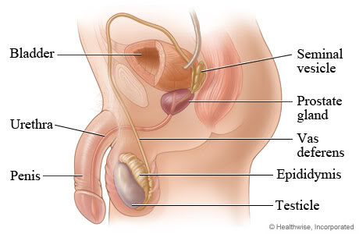
Label the diagram in regards to the anatomy discussed in class, you should be able to provide a brief explanation of each feature:

Female Anatomy
Label the diagram in regards to the anatomy discussed in class, you should be able to provide a brief explanation of each feature:
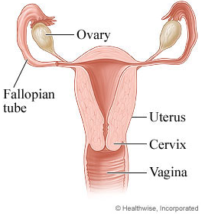

Genetics/Heredity
- Ensure you are familiar with all important vocabulary for this section
- You should be able to apply your understanding in order to solve questions
similar to those listed below:
- Oompahs generally have orange faces which are caused by a dominant gene. The recessive condition results in a blue face. Develop a “key” to show all the possible genotypes and phenotypes for the Oompah’s face colors.
Genotype | Phenotype

- Two heterozygous Oompahs are crossed. What is the probability that the offspring will have orange faces? (4 marks)

Probability of Orange face ____________

- An orange-faced Oompah (homozygous) is married to a blue-faced Oompah. They have 8 Oompah children. How many of these children will have blue faces? How many will have orange faces? (5 marks)

Probability of blue faces __________
Probability of orange faces _________
- Otis Oompah has a blue face and is married to Ona Oompah who has an orange face. They have 60 Oompah children, 30 of those children have blue faces. What are Ona and Otis Oompah’s genotypes? (2 marks)

Otis Oompah’s genotype _______ Ona Oompah’s genotype ________

- Odie Oompah has an orange face; in fact everyone in Odie’s family likes to brag that they are a “pure” line. Much to his family’s horror, he married Ondi Oompah who (gasp!) has a blue face. List the phenotypes and genotypes of Ondi and Odie’s children? Is Odie’s children still pure? (6 marks)

Genotypes of children _______________
Phenotype of children _______________
Is Odie's line still pure? YES NO

- Ona Oompah (from #10) divorces Otis and marries Otto. Otto has a blue face. What is the probability that Ona and Otto’s children will have blue faces? (4 marks)

Ona Oompah’s Probability of having children with blue faces __________

Biotechnology
You will be provided with a short article regarding a specific biotech topic. You will be required to read it over, discuss possible pros and cons, and relate it back to a specific aspect of our unit.

Additional Study Resources:
- In addition to this package, you can also study by visiting the resources available on our classroom website. To access these, please visit:
www.thompsonclassroom.weebly.com
- Grade 9 Science page
- Symbaloo (bottom of the page)
- Red Icons

** This study guide is meant to be used as a study guide, it should not be used exclusively. Please read over all class notes/materials in order to be fully prepared.

