Reproduction Unit Test
/ 60 Total Points
Name: __________________________ Date: __________________

Section (A): Matching ( / 10 Points)
Match each definition on the left with ONE vocabulary word from the right-hand column.
____ A family record showing how a trait is A. Asexual Reproduction
is inherited over generations B. Centrioles
____ Containing two dominant alleles C. Family Tree
____ Containing two recessive alleles D. Genotype
____ Containing one dominant and one recessive allele E. Heterozygous
____ Organelles that help move genetic materials through F. Heterozygous Dominant
microtubules G. Homozygous
____ Reproduction requiring only one parent H. Homozygous Dominant
____ The physical appearance of the a trait I. Homozygous Recessive
____ The process in which a cell makes an exact copy J. Meiosis
of itself K. Mitosis
____ The process in which gametes are formed L. Pedigree
____ The specific genetic make-up or code M. Phenotype

Section (B): Multiple Choice ( / 5 Points)
Select the most correct answer for each question.
1 ) In what stages is DNA duplicated in Mitosis and Meiosis?
(a) Mitosis: Interphase, Meiosis: Interphase
(b) Mitosis: Prophase, Meiosis: Interphase
(c) Mitosis: Prophase, Meiosis: Telophase 1
(d) Mitosis: Telophase, Meiosis: Metaphase
2 ) What stage is a cell’s natural state where it grows and matures?
(a) Anaphase
(b) Cytokinesis
(c) Interphase
(d) Metaphase

3 ) What is the difference between the Prophase of Mitosis & the Prophase 1 of Meiosis?
(a) DNA is already aligned in Mitosis
(b) Duplicated DNA can cross-over in Meiosis
(c) There are no condensed chromosomes in Mitosis
(d) There are no centrioles involved in Meiosis

4 ) The stages of Mitosis, in order, are:
(a) Interphase, Prophase, Prometaphase, Metaphase,
Anaphase, Telophase, Cytokinesis
(b) Prophase, Metaphase, Prometaphase, Anaphase,
Telophase, Cytokinesis, Interphase
(c) Prophase, Prometaphase, Metaphase, Anaphase,
Telophase, Cytokinesis, Interphase
(d) Prophase, Metaphase, Anaphase, Prophase 2,
Metaphase 2, Anaphase 2, Cytokinesis

5 ) The stages of Meiosis, in order, are:
(a) Interphase, Prophase 1, Metaphase 1, Anaphase 1, Telophase 1
Prophase 2, Metaphase 2, Anaphase 2, Telophase 2
(b) Interphase, Prophase 1, Metaphase 1, Anaphase 1, Telophase,
Prophase 2, Metaphase 2, Anaphase 2, Cytokinesis
(c) Prophase 1, Prometaphase 1, Metaphase 1, Anaphase 1,
Prophase 2, Metaphase 2, Anaphase 2, Telophase
(d) Prophase 1, Metaphase 1, Anaphase 1, Telophase 1, Prophase 2,
Metaphase 2, Anaphase 2, Anaphase 2, Cytokinesis

Section (C): Short Answer ( / 22 Points)
Answer each question in bullet point or sentence form. Look at each individual mark break-down to ensure your answer has enough information.
1 ) List and define two of the 5 methods of asexual reproduction that was discussed in class.
( / 4 Points)
-

-

2 ) Explain the jobs that the umbilical cord plays during fetal development.
( / 3 Points)

3 ) As a human offspring develops in the womb, it is referred to by three different names,
based on it’s level of maturity. List these names in order from least mature to most
mature. ( / 3 Points)
-
-
-
4 ) Explain the role that the prostate and seminal vesicle play in regards to successful male
gametes. ( / 2 Points)

5 ) Where must a fertilized egg implant within a woman’s body? Why is this necessary to
ensure a successful offspring? ( / 3 Points)

For questions 6 to 9, utilize the following genetic information. In Trufulla Trees, Pink Tuffs (T) is dominant and Blue Tuffs (t) is recessive.

6 ) Create a Punnett Square in which one parent Homozygous Dominant and the other is
Heterozygous. How many offspring will be: ( / 4 Points)
A ) Pink? _________
B ) Blue? _________
C ) Heterozygous? _________
7 ) Create a Punnet Square that results in two offspring with Blue Tuffs and two offspring
with Pink Tuffs. ( / 1 Point)

8 ) Create a Punnet Square that results in three offspring with Blue Tuffs and one offspring
with Pink Tuffs. ( / 1 Point)

9 ) Create a Punnet Square that results in all offspring displaying the same phenotype.
( / 1 Point)

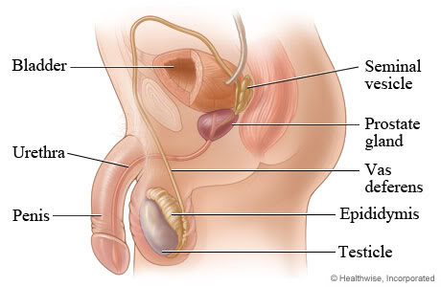
Section (D): Diagrams ( / 13 Points)
Label the male and female anatomy using the vocabulary discussed in class.

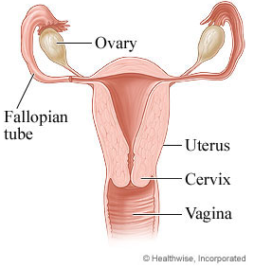

Section (E): Long Answer ( / 10 Points)
Our understanding of biotechnology and cell development has helped health-care professionals save millions of lives. Vaccines are created by exposing individuals to specific conditions in order to help build their immunity and prevent them from contracting dangerous variations of the condition.
Read the attached informational brochure on the Flu Shot, created and distributed by Manitoba Public Health and the Public Health Agency of Canada.
- List three possible PROs of the Flu Shot: - List three possible CONs of the Flu Shot:
- -
- -
- -

- List and explain one factor that might influence someone’s opinion regarding the Flu Shot:

- State and explain your opinion regarding this topic.

