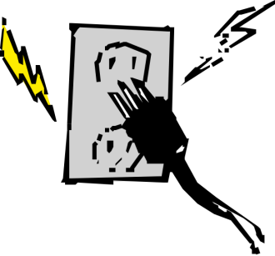
Voltage, Current and Resistance!
- A batter converts 72 J of chemical energy into Electrical energy. This places 12 C of negative charge at the negative terminal. What is the voltage between the negative and positive terminals of the battery?

- Find the current needed to supply 88 coulombs of charge in 112 seconds?

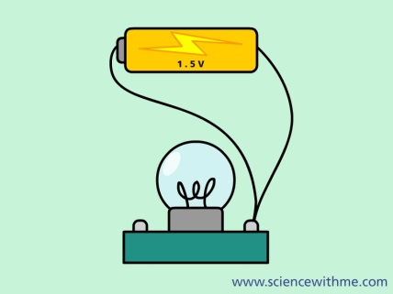
- How much energy can an electrical motor produce when it is plugged into a 110V outlet with a total charge of 50C passing through the motor?

- What unit of charge will be formed if 4 A of current move through a circuit for 30 seconds?

- How many seconds are needed for 3 A of current to produce 21 C of charge?

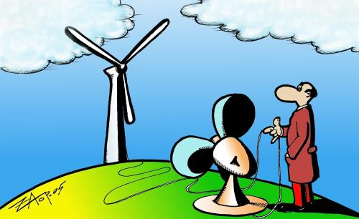
- Gasoline-powered generators charge chemical energy into electrical energy. If a generator produces 120 V with a charge of 60 C at the negative terminal. How many joules of energy are produced?

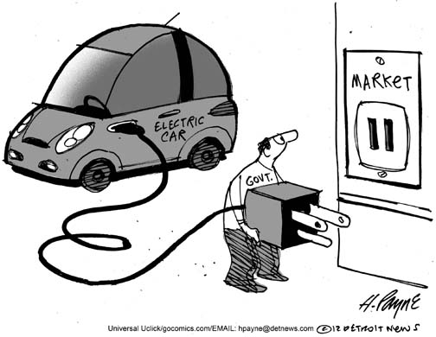
- How long will it take for 30 C of charge to have a current of 5 A?

- If a generator burned enough gasoline to produce 28 800 J, what would the coulomb charge be?

- Find the resistance of the light bulb in this circuit. The battery is 1.5 V and the ammeter is reading 85 A.

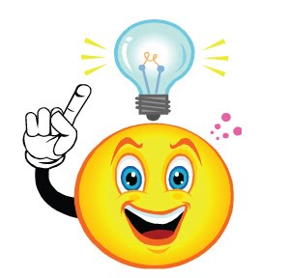
- Draw a circuit that has 2 light bulbs connected in series with a 9 V battery and ammeter.

- If the light bulbs have the same resistance as in question 9, what is the current reading on the ammeter? (hint: because there are 2 light bulbs there is twice as much resistance)

- The school’s fire alarm consist of a circuit that has a 150 ohm buzzer and a 100 ohm blinking light connected in series with a 110 V power source and a switch (closed when someone pulls the fire alarm)
  - Draw the circuit.

  - Find the current that flows through this circuit when someone pulls the alarm (remember to add the resistances together)

  - Draw a circuit with a 10 ohm resistor, a battery, an ammeter and a switch, all in series.

  - If the ammeter reads 155 A what is the voltage of the battery?

